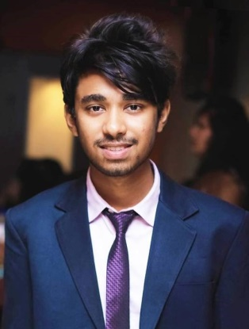

Kazi Arman Ahmed

Osmany Hall, Mirpur Cantonment, Dhaka

01679279490 

armanahmed.rahat.98@gmail.com 

github.com/R4H4T 

www.linkedin.com/in/R4H4T 

armanahmed.rahat.14 

|  |  |  |
| --- | --- | --- |
| Professional Skills | | |
| * Solidworks * Microsoft PowerPoint * Microsoft Word * C programming * micro C * Python * Programmable Logic Controller (PLC) * Blender * Microcontroller & Robotics * Attended workshop on presentation skills * Adobe Photoshop | | |
| Personal Skills | | |
| * Team Work * Creativity * Leadership * Debate | | |
| Work Experience | | |
|  |  | Assistant Secretary(Publication)  *MIST Debating Society*   * Organizer of “Idea Hamster 2017” * Organized “Intra University Debate Competition 2017”   Executive Member (Publication)  *MIST Robotics Club*   * Organizing member of “Robolution 2017” * Organizing member of “Robolution 2018” * Member of Publication “SIngularity 2017” |
| Education | | |
| 2016 – Present |  | Bachelor of Science in Industrial & Production Engineering  *Military Institute Of Science & Technology – Mirpur Cantt., Dhaka*  *CGPA:- 3.49*  . |
| 2013 – 2015  2008– 2013 |  | Higher Secondary Certificate (HSC)  *Chittagong Cantonment Public College– Chittagong Cantt., Chittagong*  GPA:- 5.00  Secondary School Certificate (SSC)  *Nasirabad govt. Boys’ High School – Nasirabad, Chittagong*  GPA:- 5.00 |

|  |  |  |
| --- | --- | --- |
|  | | |
| 2018 |  |  |
|  |  | 2nd Runner up in “Master Mind” at “Robolution 2018”  2nd Runner up in “Business Idea Challenge” at “Business Innovation Summit 2018”  1st Runner up in “IT Business Idea Challenge” at “Technovation 2018”  2nd Runner up in “Microcontroller Project” at “Intra University Robotics Competition 2018”  Participated in “Idea Generation” at “Engenius’2018” |
| 2017 |  | 1st Runner up in “Design & Simulation” at “National Robotic Festival 2017”  Participated in “Hult Prize”  Champion in Inter Dept. Football Competition at MIST  Champion in Inter Hall Football Competition at MIST |
| 2016 |  | Participated in “Robofight” at “Robolution 2016” |
| 2010 |  | Gold Medalist in “Intra District Karate Competition” at Chittagong |

Activities & Awards